Paper Title (Times New Roman Bold 14)
Author Name1^{1*}, Author Name2¹, Author Name3²
¹ Department of Biochemistry, College of Medicine, University of Thi Qar, Thi Qar, Iraq
² Department of Nursing, College of Health and Medical Technology, Sulaimani Polytechnic University, Sulaimaniyah, Iraq
Corresponding Author Email: corresponding.author@email.com
Abstract (Times New Roman Bold 11)
Received:
Revised:
Accepted:
DOI:
10.32792/jmed.vxxxx.xxx
Keywords:
Keywords1
Keywords2
Keywords3
Keywords4
How to cite

Author Name1, Author Name2, Author Name3. Paper Title. Thi-Qar Medical Journal (TQMJ). Year;Volume(Issue):Page numbers.

In the Thi-Qar Medical Journal, submissions addressing various aspects of medical and clinical research are encouraged. The abstract must be a single paragraph of no more than 250 words, clearly outlining the study's objective, assumptions, methodology, key results, and conclusion. It should be concise and informative, without the use of equations, figures, tables, or references. The abstract must be formatted in Times New Roman, 10-point font size, justified alignment, and single line spacing. n the Thi-Qar Medical Journal, submissions addressing various aspects of medical and clinical research are encouraged. The abstract must be a single paragraph of no more than 250 words, clearly outlining the study's objective, assumptions, methodology, key results, and conclusion. It should be concise and informative, without the use of equations, figures, tables, or references. The abstract must be formatted in Times New Roman, 10-point font size, justified alignment, and single line spacing. n the Thi-Qar Medical Journal, submissions addressing various aspects of medical and clinical research are encouraged. The abstract must be a single paragraph of no more than 250 words, clearly outlining the study's objective, assumptions, methodology, key results, and conclusion. It should be concise and informative, without the use of equations, figures, tables, or references. The abstract must be formatted in Times New Roman, 10-point font size, justified alignment, and single line spacing. n the Thi-Qar Medical Journal, submissions addressing various aspects of medical and clinical research are encouraged. The abstract must be a single paragraph of no more than 250 words, clearly outlining the study's objective.
Copyright: ©2025 The authors. This article is published by the Thi-Qar Medical Journal and is licensed under the CC BY 4.0 license

- General Guidelines
  - Structure
Your paper should be compiled in the following order: title page; abstract; keywords; main text introduction; materials and methods; results and conclusions; acknowledgments; and references.
  - Page Limits
Use Microsoft Office Word 2007 or later to write the article. Please include a page count for your paper.
  - Formatting and Templates
Papers should be submitted in Word format. Author details All authors of a manuscript should include their full name and affiliation on the first page of the manuscript. Where available, please also include the ORCiDs code. One author will need to be identified as the corresponding author. Authors’ affiliations are the affiliations where the research was conducted. Please note that no changes to affiliation can be made after your paper is accepted.
- Preparing Your Submission
Authors are advised to consult a recent issue of the Journal for guidance on style and layout. All papers must be written in clear, concise English. In general, research papers should be in an impersonal form.
  - Title
This should be concise and explain the nature of the paper. If the paper was given, wholly or in part, at a scientific meeting, this should be stated in a footnote.
  - Author Names
These should include, the name and surname of each author spelled in full, and the address where the work was carried out. The name, address, email address, and phone number of the corresponding author should be indicated clearly. Authors' names must not appear anywhere in the paper when this is first submitted to the organizers.
  - Abstract
must contain 150 to 200 words in a three-part format with three uppercase-headed sections
  - Keywords
Appropriate keywords (3 - 7) should be provided for indexing and abstracting.
  - Introduction
The introduction must have the number 1.
  - Methodology and Approaches
The methods and materials used should be stated clearly.
  - Results and Conclusions
Results and Conclusions should include (1) the principles and generalizations inferred from the results, (2) any exceptions to, or problems with these principles and generalizations, (3) theoretical and/or practical implications of the work, and (5) conclusions drawn and recommendations.
  - Tables
Each table should be numbered consecutively (1, 2, etc.). The Table header should be placed at the top (example).
Table 1. Header (Tımes New Roman, 8 Font Sıze, Bold)
Time | Tonnage (Mt)
t=1 | 1/5
t=2 | 2

The Table in the manuscript should be given in the following format. For example, Table 1. in the manuscript should be written as Table 1
  - Figures
All photographs, graphs, and diagrams must be referred to as “Figures” and numbered consecutively (e.g., Fig. 1, Fig. 2, etc.). Multipart figures should be labeled using lowercase letters (a, b, c, etc.). Figure captions must be placed below the corresponding figure. Authors are required to submit figures in high-resolution formats—minimum 300 dpi for photographs—using one of the following preferred file types: JPG, JPEG, or TIFF.

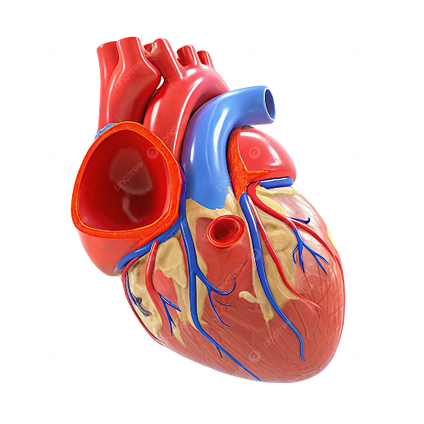
Fig. 1. Header (Tımes New Roman, 8 Font Sıze, Bold)
The Figure in the manuscript should be given in the following format. For example, Fig. 1. in the manuscript should be written as Fig. 1

Acknowledgments
Acknowledgments must be unnumbered. These should be kept to a minimum. Authors should list all funding sources in the Acknowledgments section. Authors are responsible for the accuracy of their funder designation.

REFERENCES
All references should be numbered sequentially in order of appearance and as thorough as feasible. Citations in the text should be in numerical sequence, using Arabic superscript numerals. Citing and referencing: Vancouver and add DOI for each reference:
- Huang AL, Bosco JJ, Peter K. Mast Cell: An Un-expected Villain in Venous Thromboembolism?Circulation Research. 2017;121(8):899-901.doi:https://doi.org/10.1161/CIRCRESAHA.117.311777
- Ahad A.; Direct Oral Anticoagulants in The Treatment Of Acute Venous Thromboembolism in Patients With Obesity. Journal of Biomedicine and Biochemistry. 2023;2(3):17-27. doi:10.57238/jbb.2023.6960.1038

